Sample- Datasheet- this is my design, do not copy it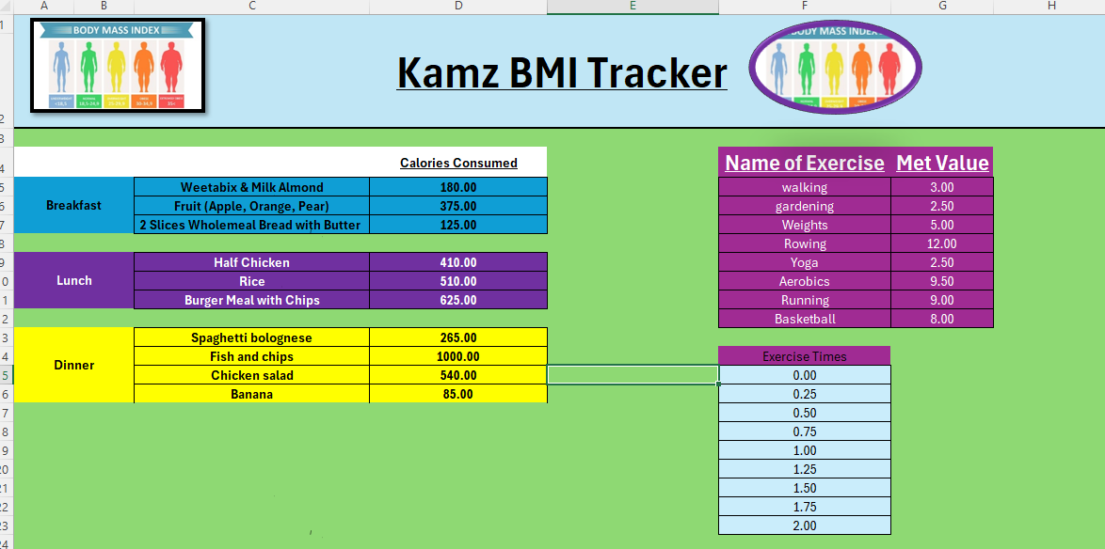

Sample- Start Sheet- this is my design, do not copy it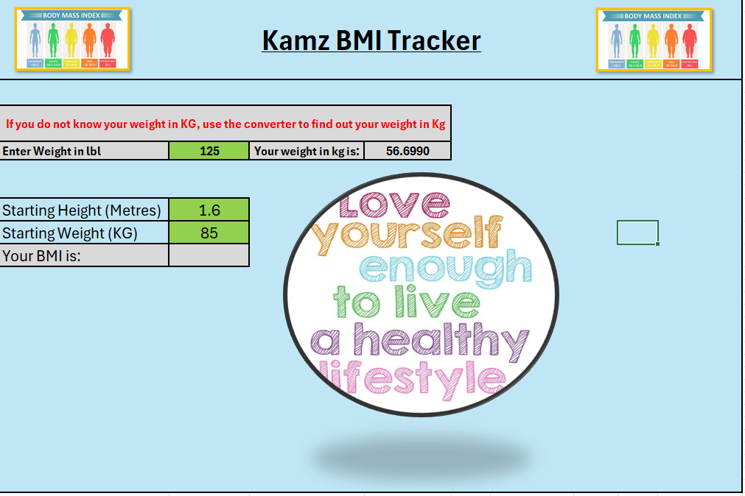
Week 1 Day 1- Examples 